Ideation Phase
Empathize & Discover

Date | 31 January 2026
Team ID | Gemini Pro Financial Decoder
Project Name | LTVIP2026TMIDS61777
Maximum Marks | 4 Marks

Empathy Map Canvas
An Empathy Map Canvas is a visual tool used to understand users by analyzing their behaviors, thoughts, emotions, challenges, and needs. It helps the team understand the problem from the customer's perspective and design a user-centered AI solution.
For the Gemini Pro Financial Decoder project, the empathy map focuses on users who need quick and clear financial analysis from complex financial data.
Understanding both emotional and practical difficulties helps in developing a simple, fast, and reliable AI-powered financial analysis system.

🎯 Target Users
• Financial Analysts
• Business Owners / CEOs
• Startup Founders
• Accountants
• Financial Journalists

🧠 Empathy Map Analysis
Think
• I need to understand financial performance clearly.
• I need to identify trends and key insights quickly.
• I want to make better business decisions based on data.
• I do not want to spend hours analyzing spreadsheets.

Feel
• Overwhelmed by large financial datasets.
• Confused by complex tables and financial jargon.
• Stressed when deadlines are near.
• Confident when insights are clear and easy to understand.

Say
• “I need a clear summary of this financial report.”
• “This spreadsheet is too complicated.”
• “I wish there was a tool that could explain these numbers.”
• “I need quick insights before my meeting.”

Do
• Reviews financial statements manually.
• Calculates totals and trends using Excel.
• Searches online for financial analysis help.
• Prepares reports and presentations manually.

⚠ Pain Points
• Financial data is complex and time-consuming to analyze.
• Large spreadsheets are difficult to interpret quickly.
• Non-financial users struggle with financial terminology.
• Manual analysis increases risk of human error.

🎯 Gains (User Needs)
• Quick and accurate financial insights.
• Clear summaries without technical jargon.
• Visual dashboards and charts for better understanding.
• Easy-to-use web application.
• Faster decision-making support.

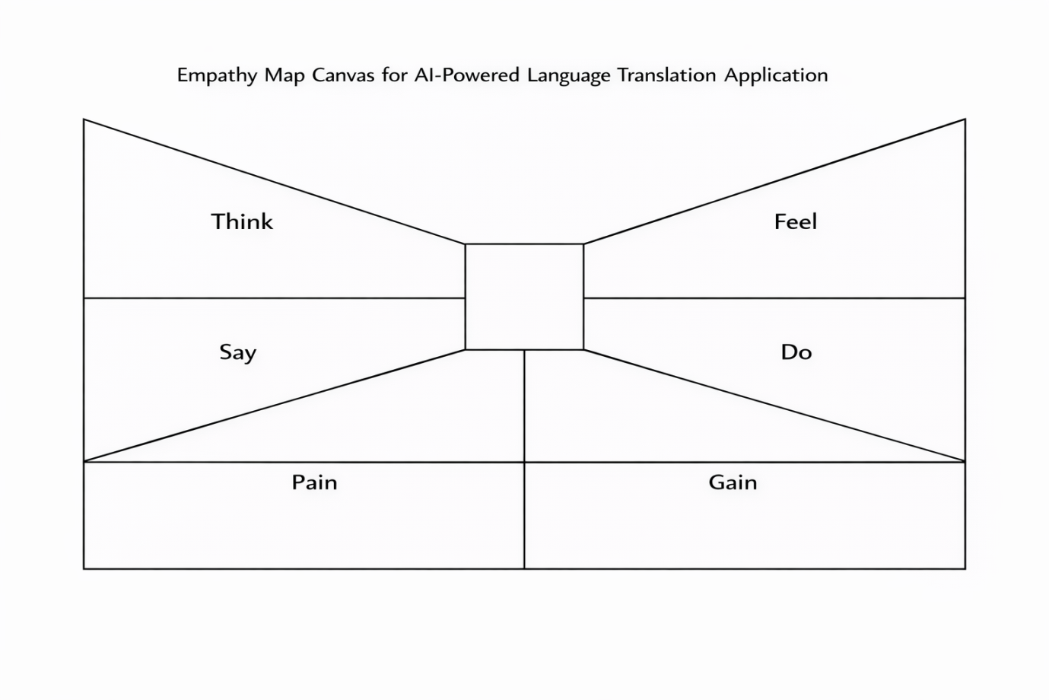

Conclusion
By understanding the user’s thoughts, feelings, challenges, and expectations, the Gemini Historical Artifact Description project is designed to provide a practical and user-centered solution using Generative AI technology.

